Forum: General Assembly
Issue: Addressing the Refugee Crisis in Europe
Student Officers: Olivia Noh, Donghyun Ku, Franziska Müller
Positions: President, Assistant President, Assistant President

Introduction
The European refugee crisis has reached critical levels, driven by geopolitical maneuverings that utilize human displacement as a tool of influence. Over the past several years, the ongoing conflict in Syria has created millions of refugees, many of whom have sought sanctuary in European countries. This has been compounded further by mounting allegations of Russia actively encouraging refugee flow to destabilize European states, especially as a counter to rising political tensions. Finland's recent shutdown of Russian border points, for example, mirrors growing suspicion over organized migration attempts, prompting pressing questions regarding Moscow's actual motives and tactics.
Finnish Border Guards escort the migrants at the international border crossing at Salla, northern Finland, November 23, 2023
As the crisis persists, the world is faced with severe humanitarian and political consequences. Not only are the refugees a burden on receiving countries, but they also excite public opinion, which influences national policy and has a tendency to turn immigration into a subject of extremely polarized debates. This too, can continue to complicate the political situation within Europe as governments grapple with a way of addressing the refugees' needs and those of its own nationals. The topic for this conference, "The Ripple Effect" is appropriately chosen, indeed, the refugee crisis demonstrates how one conflict or policy decision can create waves of displacement, political upheaval, and societal change across continents. Each reaction—whether humanitarian aid, border closures, or xenophobic backlash—creates further ripples, proving how interconnected and far-reaching such crises can be.
This crisis demands a mature comprehension of the principal actors, the politics of the refugee stream, and the possibility of effective international cooperation. In meeting these challenges, we can move towards a more sustainable system that serves the refugees and the countries under the strain of this crisis better. We must have action and dialogue that clear the way towards a more humane and efficient response to this appalling global crisis.

Definition of Key Terms

Asylum Seeker - someone who has or intends to apply to be recognized as a refugee, but their application has yet to be processed.
Refugee - A person who has fled their home country due to a well-founded fear of persecution based on race, religion, nationality, political opinion, or membership in a particular social group.
Internally Displaced Person (IDP) - Someone who has been forced to flee their home but remains within their country’s borders. Unlike refugees, IDPs are not protected by international law in the same way.
Dublin Regulation - An EU law that determines the member state responsible for processing an asylum application. Typically, this is the first EU country the asylum seeker entered. The regulation has faced criticism for placing disproportionate pressure on border states like Greece and Italy.
Humanitarian Corridor - A safe passage created to allow civilians and vulnerable populations, including refugees, to escape conflict zones and receive aid. These are often negotiated through international cooperation.
Schengen Area - A zone comprising 27 European countries that have abolished passport and other types of border control at their mutual borders. The refugee crisis challenged the integrity of this area, as some states reinstated border checks due to the influx of migrants.
EU Relocation Scheme - A temporary policy initiated by the European Union in 2015 aimed at redistributing asylum seekers from high-pressure countries like Greece and Italy to other EU member states, though implementation was inconsistent and controversial.

Background
Overview of the EU refugee crisis
The EU refugee crisis is one which has been tried to be combated by the European Union for over a decade, and had extensive humanitarian, political, and logistical implications across the continent. Between the years of 2015 and 2016 the crisis reached its peak as over 2.3 million asylum applications were made across EU countries, where the highest number of applications was received in Germany at over 970,000 applications for asylum in 2015 (Eurostat, 2016). Most of these migrants and refugees were from war-torn nations such as Syria and Afghanistan. They were fleeing conflict with armed groups, persecution, and severe economic desperation. The Syrian civil war alone resulted in more than 6.8 million refugees around the world, according to the UNHCR, thereby emerging as one of the largest displacement crises in recent history. Many of these individuals embarked on journeys across the Mediterranean Sea, where, as of 2024, more than 29,000 migrants have died or gone missing since 2014 (IOM, 2024).
Strain on Border Countries
Due to the often-chosen way through the Mediterranean Sea, EU border states like Greece and Italy became main points of entry, resulting in overloaded reception centers and overcrowded refugee camps. For instance, the Greek island of Lesbos's Moria camp, which was supposed to hold up to 3,000 residents, housed over 20,000 at its peak, this led to unsanitary and dangerous living conditions (Human Rights Watch, 2020). To combat illegal migration and support first arrival countries, the EU-Turkey deal in 2016 was created to move migrants who reached Greece to Turkey in exchange for funding and guarantees to resettle Syrian refugees directly from Turkey. While the deal aimed to support the number of arrivals, it was widely criticized by NGOs and human rights groups as a violation of international asylum rights and as tending to create a bottleneck effect on Greek islands.
Political Reactions and ongoing challenges
From a political view, the refugee crisis is a key cause of the increased emergence of anti-immigration forces in Europe. Nations such as Hungary and Italy established tougher immigration legislation, which is testing EU solidarity and reinforcing the bloc's migration policy fragmentation. The Dublin Regulation which states that asylum applicants must claim asylum in the first EU state in which they arrive, was sharply criticized as over-burdening the border countries. Despite all the reform processes, the EU has struggled to introduce a coherent asylum policy striking a balance between humanitarian obligations on one hand and national interests on the other. The refugee crisis remains one of the most contentious and outstanding issues in EU policy, and more cooperation, burden-sharing, and persistent solutions that respect both security concerns and rights of the displaced are needed.

Major Parties Involved:

European Commission
The commission has been actively developing migration and asylum policies to alleviate the refugee crisis. The policies they are upholding include protecting shelters, curbing irregular migration, guaranteeing free movements, establishing better organizations of legal migration, and better integration of non-EU nationals into EU societies. Their purpose and objective are to ensure all European countries fully implement the Common European Asylum System (CEAS), promote legal migration and return policy, and protect the external borders.

Greece
Greece, along with Italy and Spain, is one of the few countries that accepted overwhelming numbers of refugees. In 2015, thousands of people fleeing war and poverty arrived daily on Greek islands like Lesbos, often risking their lives on dangerous sea crossings from Turkey after paying traffickers nearly €1,000 each. Many were moved to camps such as Moria, where conditions were dire—overcrowded, unsanitary, and lacking necessities. However, in March 2016, the Greek authorities transformed reception facilities into detention centers following the EU–Turkey deal. This led to mass returns to Turkey and leaving over 50,000 refugees stranded in Greece.
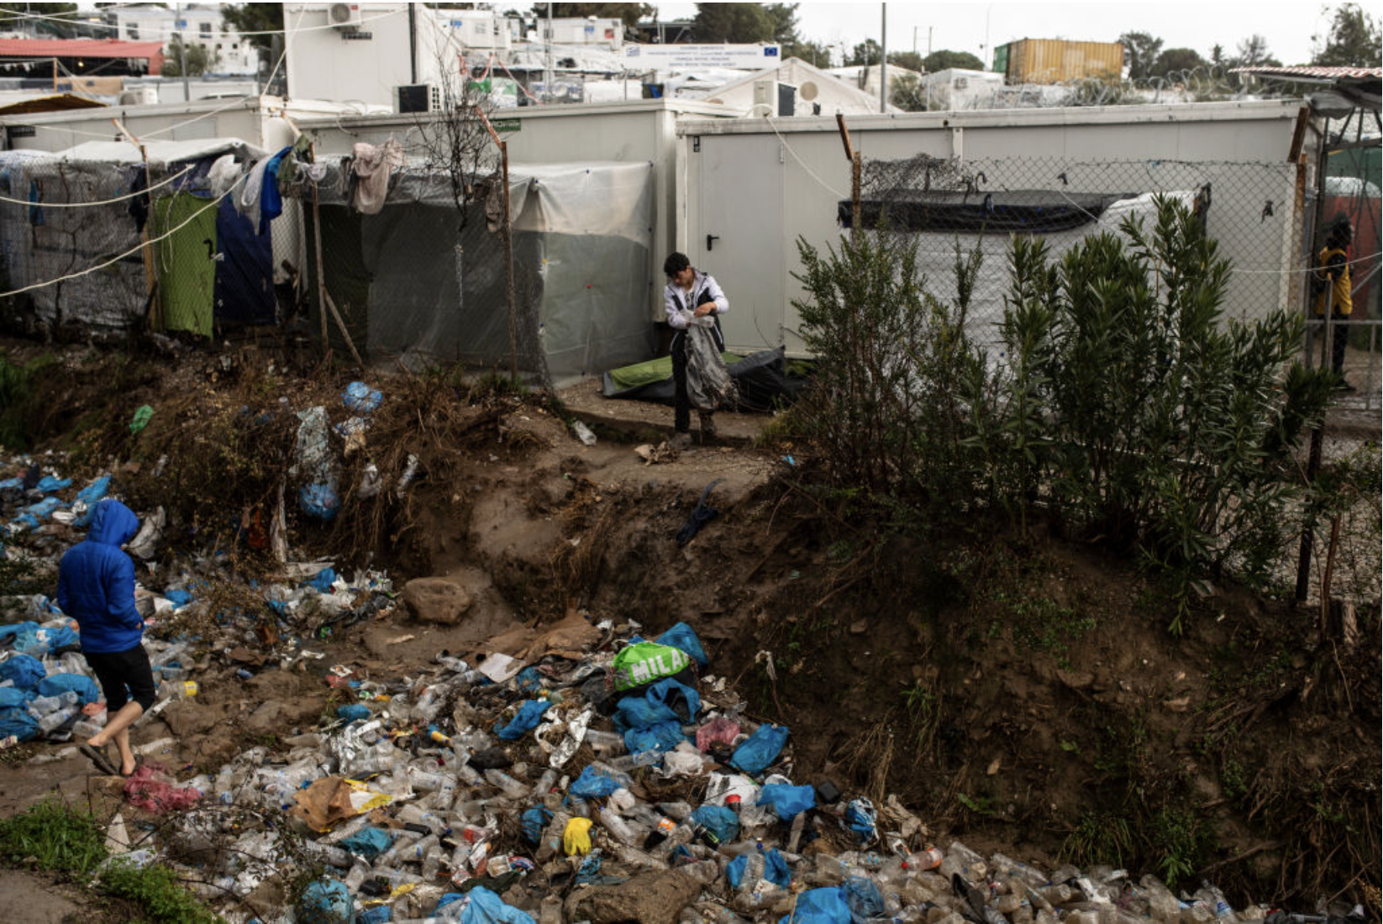
Syrian refugees living in a Moria Refugee Camp, surrounded by makeshift shelters and piles of waste in 2020

United Nations High Commissioner for Refugees
The United Nations High Commissioner for Refugees (UNHCR) has been on the action since the start of the crisis. In response, UNHCR has been providing shelters, meals, lifesaving supplies, clean water, and medical care to displaced families. UNHCR and its partners are developing humanitarian aid to support the huge needs of returnees as well.

Previous Attempts to Resolve the Issue:

- EU-Turkish deal
In March 2016, European nations and Turkey signed an agreement aiming to curb the flow of refugees to Europe. In this deal, the Turkish government agreed to take back all the illegal immigrants who have crossed Greece’s border. Straightforwardly, the agreement reduced the number of illegal immigrants, but it faced many problems, like human rights violations or precarious conditions in which many refugees lived.

- Dublin Regulation Reforms
The Dublin Regulation, which was the determinant in deciding which EU member states were responsible for refining asylum applications, has been a very crucial point for reform efforts. There have been various amount of proposals made to allocate asylum seekers more adequately among EU countries, such as Germany, France, and Italy, which were all aimed towards alleviating the unbalanced burden that brought on the burden onto frontline states like Italy and Greece. However, these proposals have struggled to gain the attention of member states, which is continuously leading to ongoing debates about the sufficiency and effectiveness of the current asylum system that is currently followed.

Possible Solutions:

- Better protection in regions – It is important to keep secure protection so that people can remain close to their homes in safety and dignity. The European Union already has regional protection frameworks in place, however extended effort to implement this solution effectively is needed.

- More refugees need to be offered the opportunity to resettle permanently in Europe. Of the almost 17 million refugees in the world today, around 100,000 each year are given the opportunity to join programs that take them from refugee camps to More Economically Developed Countries (MEDCs) to settle. Almost all of these places are offered by the United States, Canada and Australia. Resettling more refugees in this way will never be at a scale sufficient to satisfy demand, but it’s a way to demonstrate solidarity with the Less Economically Developed Countries (LEDCs) that continue to shoulder the burden of the refugee crisis.

Bibliography

European Commission. “The EU-Turkey Statement.” European Commission, 18 Mar. 2016, https://ec.europa.eu/home-affairs/what-we-do/policies/asylum/eur-1_en.
European Commission. "Country Responsible for Asylum Application (Dublin Regulation)." Migration and Home Affairs, https://home-affairs.ec.europa.eu/policies/migration-and-asylum/common-european-asylum-system/country-responsible-asylum-application-dublin-regulation_en. Accessed 6 May 2025.
European Council. "Response to the Migration Crisis and Force Majeure Situations." Consilium, https://www.consilium.europa.eu/en/policies/migration-crisis/. Accessed 6 May 2025.
European Parliament. “Dublin Regulation: An Overview.” European Parliament, 2021, https://www.europarl.europa.eu/factsheets/en/sheet/151/dublin-regulation.
Migration Policy Institute. “The EU's Response to the Refugee Crisis: A Review of the Dublin System.” Migration Information Source, 2022, https://www.migrationpolicy.org/article/eu-response-refugee-crisis-review-dublin-system.
Oxfam International. “Stranded in Greece: The Long Refugee Road to Nowhere.” Oxfam International, 25 May 2022, www.oxfam.org/en/stranded-greece-long-refugee-road-nowhere.
Syrian Association for Citizens’ Dignity. “Refugees: A Russian Weapon to Empty Syria and Flood Europe!” Syrian Association for Citizens’ Dignity, 18 Dec. 2023, https://syacd.org/refugees-a-russian-weapon-to-empty-syria-and-flood-europe/. Accessed 4 May 2025.
“Migration and Asylum.” European Commission, https://commission.europa.eu/topics/migration-and-asylum_en.
Time. “UN Calls for ‘Emergency Measures’ to Improve Conditions in Greek Refugee Camps, amid Overcrowding and Risk of Disease Outbreaks.” Time, https://time.com/5781936/lesbos-greece-refugee-camps-dangerous/.
UNHCR. “Syrian Refugee Crisis: Aid, Statistics and News.” USA for UNHCR, 2024, www.unrefugees.org/emergencies/syria/.
United Nations Academic Impact. "Europe and the Refugee Crisis: A Challenge to Our Civilization." United Nations, https://www.un.org/en/academic-impact/europe-and-refugee-crisis-challenge-our-civilization. Accessed 6 May 2025.
United Nations High Commissioner for Refugees. "Asylum-seekers." UNHCR, https://www.unhcr.org/about-unhcr/who-we-protect/asylum-seekers. Accessed 6 May 2025.
United Nations High Commissioner for Refugees. "Internally Displaced People." UNHCR, https://www.unhcr.org/about-unhcr/who-we-protect/internally-displaced-people. Accessed 6 May 2025.
United Nations High Commissioner for Refugees. "Refugees." UNHCR, https://www.unhcr.org/about-unhcr/who-we-protect/refugees. Accessed 6 May 2025.
United Nations High Commissioner for Refugees. Global Trends: Forced Displacement in 2022. UNHCR, 2023, https://www.unhcr.org/globaltrends2022/.
USA for UNHCR. "Refugee Crisis in Europe: Aid, Statistics and News." USA for UNHCR, https://www.unrefugees.org/emergencies/europe/. Accessed 6 May 2025.

